StoLaM+
Effect calibration results

Dr. Tido Strauss
Jana Gerhard
Natalie Dallmann

gaiac - Research Institute for Ecosystem Analysis and Assessment
Kackertstr. 10
52072 Aachen
Germany

October 21, 2022

1 Introduction 3
2 Effect models 3
2.1 Exposure scenarios 3
2.2 TKTD Modelling 4
2.3 Other toxicological approaches 7
3 Result overview and short discussion 7
3.1 Direct effects 7
3.1.1 Daphnids 7
3.1.2 Copepods 8
3.2 Indirect effects 8
3.2.1 Rotifers 8
3.2.2 Phytoplankton 8
3.2.3 Chaoborus crystallinus 10
3.3 Toxicologically unaffected benthic taxa 11
3.4 Summary 11
4 Graphic results StoLaM 12
4.1 Zooplankton 12
4.1.1 Daphnids 12
4.1.2 Copepod naupli 14
4.1.3 Predatory (cyclopoid) copepods 15
4.1.4 Rotifera 16
4.2 Phytoplankton 17
4.2.1 Total Chlorophyll-a 17
4.2.2 Green algae 18
4.2.3 Diatoms 19
4.2.4 Cryptophytes 20
5 Graphic results IBM Chaoborus 21
5.1.1 Chaoborus crystallinus 21
6 Graphic results StreamCom 22
6.1 Macroinvertebrates 22
6.1.1 Asellus aquaticus 22
6.1.2 Gammarus 22
6.1.3 Gastropoda 23
6.1.4 Cloeon dipterum 23
6.1.5 Chironomus riparius 24
7 Appendix A: GUTS parametrisation 25
7.1 Zooplankton 25
7.1.1 Daphnia 25
7.1.2 Copepods 27
7.1.3 Chaoborus crystallinus 28
7.2 Macroinvertebrates 29
7.2.1 Cloeon dipterum 29
7.2.2 Gammarus pulex 30
7.2.3 Asellus aquaticus 31
7.2.4 Lymnea stagnalis 32
7.2.5 Chironomus riparius 33

Introduction

In this report, based on the previously calibrated StoLaM+ model frame works, the effect model calibrations and the effects of the mesocosm exposure scenarios are shown and briefly discussed in comparison with the experimental data for the year 2019.

The simulations always started on 01 January 2019.
The simulations of the pelagic planktonic system were calculated with StoLaM with 50 Monte Carlo simulations each. Chaoborus was simulated with the IBM Chaoborus model with 200 Monte Carlo simulations, the number of Monte Carlo simulations for the benthic invertebrates with the StreamCOM model was set to 100.

The result sections present the simulation results of the modeled taxa for the mesocosm study 2019b. The figures integrate the control and treatment mean values of the Monte Carlo simulations as well as experimental mesocosm data (upper graph). In the lower graph, the range of MDD values from the mesocosm study is combined with the measured and simulated effect size (relative deviation of the treatments from the controls).

Effect models and exposure

The GUTS framework (Jager et al. 2011) was used as effect models to simulate the influence of azoxystrobin for the pelagic and benthic invertebrates.

Exposure scenarios

The day of the first application of azoxystrobin (06/13/2019) is day 0 in the mesocosm study, and in terms of the whole simulated year, day 164 (day of the year). The exposure scenarios used for the simulation were read in daily from a file (see Figure 1).

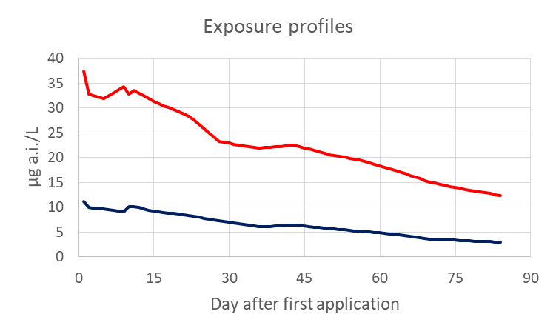
Figure 1: Exposure profiles for the 30 µg/L (red line) and the 10 µg/L (black line) azoxystrobin profile of the mesocosm study 2019b.

TKTD Modelling

The GUTS framework involves different dose metrics and toxicodynamic assumptions. The dose metric links an external concentration to internal damage and includes toxicokinetic processes such as bioaccumulation and distribution as well as damage accrual, recovery and physiological compensation processes (Jager et al. 2011).
We used the reduced version (GUTS-RED) which combines all those processes and makes use of the scaled internal concentration as the dose metric, selected stochastic death (SD) as the toxicodynamic assumption.
In case of GUTS-RED-SD, the model setting refers to three major parameters: the dominant rate constant kd, the effect threshold z, and the killing rate kk, which describe the effect and depend on the specific species/substance combination.

The laboratory tests were conducted with azoxystrobin [µg a.i./L] over 48 h (see Table 1). For GUTS calibration, only the values for the technical material were used.

The TKTD Parameter for the GUTS effect model were calibrated either with OpenGUTS (vers. 1.0) or MORSE package (vers. 3.3.1).
For the joint calibration of multiple data sets without (Daphnia) or with (copepod) size dependence, the GUTSplus (vers. 1.1) program was used.

Conceptually, it would be optimal to use the GUTS parameters calibrated in laboratory tests, measured for the correct species and over an appropriately long period of time for the concentration range needed in the application, unchanged in the simulation of field scenarios.
However, in these laboratory tests available in this project, the organisms were only tested for 48 h at mostly much higher concentrations than in the mesocosm study. In addition, the species and/or size stages were often different.

For benthic macroinvertebrates and Chaoborus larvae, the unmodified GUTS parameterisations from the lab studies were used (see Table 1 and Chapter 7: Appendix A: GUTS parametrisation). For these species, there was no evidence of inconsistencies with the mesocosm data. However, the only plausibility check on the results was that no direct effects should be apparent in either the simulation or the experimental mesocosm study for the given exposure scenarios.

In the case of Daphnia, its sensitivity in the short term laboratory tests with technical material is too low to reproduce the clear adverse effects in the mesocosms in the 30 µg/L exposure scenario (Figure 2, left panel).
Therefore, the GUTS parameters were recalibrated directly on the mesocosm data 2019b from the two upper exposure scenarios (Figure 2, middle panel).
Although the data can be reproduced well with this parameter set, the threshold z for the daphnids was additionally lowered from 31.31 to 28 based on the population modeling results. Although a pure GUTS simulation does not fit the mesocosm data set as well (Figure 2, middle panel), the prediction on population level has become better (Figure 6, page 12).
The GUTS parameters ultimately used are given in (Table 2).

Table 1: GUTS calibrations based on the single species laboratory tests (see also chapter 7: Appendix A: GUTS parametrisation)
Parameter | kd | z | kk | Study information*
Description | dominant  rate constant | threshold  for lethal effect | killing rate
Unit | 1/d | µg/L | l/(µg*d) | References | size /  stage | calibration program
Cloeon dipterum | 4.5 | 2050 | 0.00033 | Farelly et al. (1995): ICIA5504: Comparative toxicity of the technical material in solution and a 500 g kg-1 WG formulation to the mayfly nymph Cloeon dipterum. Confidential report series RJ1795B. | 5 mm | openGUTS
Gammarus pulex | 1.06 | 132 | 0.00747 | Farelly et al. (1995): ICIA5504: Comparative toxicity of the technical material in solution and a 500 g kg-1 WG formulation to the mayfly nymph Gammarus pulex. Confidential report series RJ1782B. | 5 mm | openGUTS
Asellus aquaticus | 0.122 | 471.8 | 0.00232 | Farelly et al. (1995): ICIA5504: Comparative toxicity of the technical material in solution and a 500 g kg-1 WG formulation to the mayfly nymph Asellus aquaticus. Confidential report series RJ1789B. | 5 mm | openGUTS
Lymnaea stagnalis | 0.474 | 2064 | 0.00037 | Farelly et al. (1995): ICIA5504: Comparative toxicity of the technical material in solution and a 500 g kg-1 WG formulation to the mayfly nymph Lymnaea stagnalis. Confidential report series RJ1796B. | 15 mm | openGUTS
Chironomus riparius | 1.704 | 209 | 5.448 | Farelly et al. (1995): ICIA5504: Comparative toxicity of the technical material in solution and a 500 g kg-1 WG formulation to the mayfly nymph Chironomus riparius. Confidential report series RJ1790B. | second instar | openGUTS
Daphnia longispina | 28.56 | 224 | 0.2849 | Farelly et al. (1995): ICIA5504: Comparative toxicity of the technical material in solution and a 500 g kg-1 WG formulation to the mayfly nymph Daphnia magna. Confidential report series RJ1797B. | first instar | openGUTS
Cyclopoid copepods | 43.65 | 92.32 | 0.01968 | Farelly et al. (1995): ICIA5504: Comparative toxicity of the technical material in solution and a 500 g kg-1 WG formulation to the mayfly nymph Macrocyclops fuscus. Confidential report series RJ1793B. | 2 mm | openGUTS
Chaoborus crystallinus | 11.952 | 464 | 0.00031 | Farelly et al. (1995): ICIA5504: Comparative toxicity of the technical material in solution and a 500 g kg-1 WG formulation to the mayfly nymph Chaoborus crystallinus. Confidential report series RJ1792B. | Phatom midge larvae | MORSE

* study duration always 48 h; only data for technical material used for calibration

This calibration strategy now provides a GUTS parameter set for Daphnia that can well reproduce the calibration data from the 2019b mesocosm study (Figure 6, page 12).
The laboratory data set was not further used for calibration. Unfortunately, the NOEC for sublethal effects in a Daphnia reproduction study for the same compound was also above the highest exposure concentration in the mesocosm study and therefore was not considered further as an alternative data set for calibration.

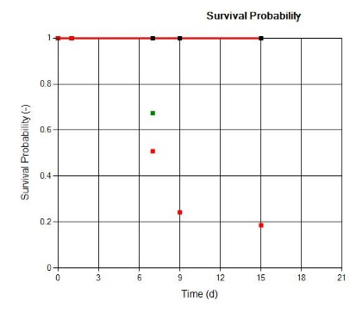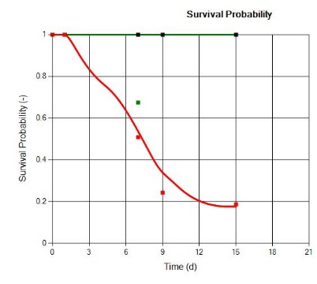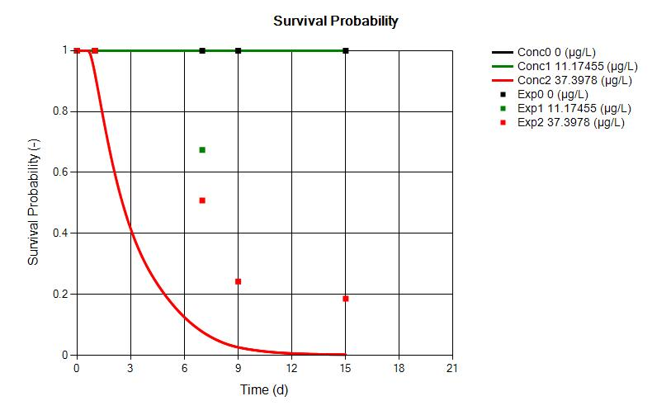
Figure 2: Simulations of daphnid survival using mesocosm data 2019b (red: 30 µg/L exposure scenario, green: 10 µg/L exposure scenario); dots: mesocosm data, lines: simulations. X-axis: day after first application in the mesocosm study. Left: GUTS parameters obtained from the laboratory study (OpenGUTS); middle: GUTS parameters calibrated to mesocosm data (GUTSplus, z=31.3); right: GUTS parameters re-calibrated to mesocosm data during the population modelling (z=28).

Also in the case of the cyclopoid copepods (Macrocyclops fuscus), its sensitivity in the short term laboratory tests with technical material is too low to reproduce the clear adverse effects in the mesocosms in the 30 µg/L exposure scenario neither for the adults nor the smaller copepodite and nauplius stages (Figure 3, upper panels).
On the other hand, the mesocosm data show clear sensitivity differences between copepod stages of different sizes, with higher sensitivity of the small larvae.
For these reasons, the laboratory data set was not used further, but the information for calibrating the size-sensitive GUTS parameters for the cyclopoid copepods was taken from the acute effect phase of the 2019b mesocosm study.
The length correction of the GUTS parameter kd was calculated as:
kd*=kd*Lm/L
with kd: value for the largest size class
Lm: Maximum length of the largest size class (here: 2 mm)
L: Current length of the individual [mm]
kd*: size corrected value for kd

With these calibrations made simultaneously for all size stages using the GUTSplus program, the size-dependent effects are well represented in the 30 µg/L exposure scenario, and shows only a very slight effect in the 10 µg/L exposure scenario for the very small nauplius larvae (Figure 3, lower panels). The GUTS parameters ultimately used are given in (Table 2).

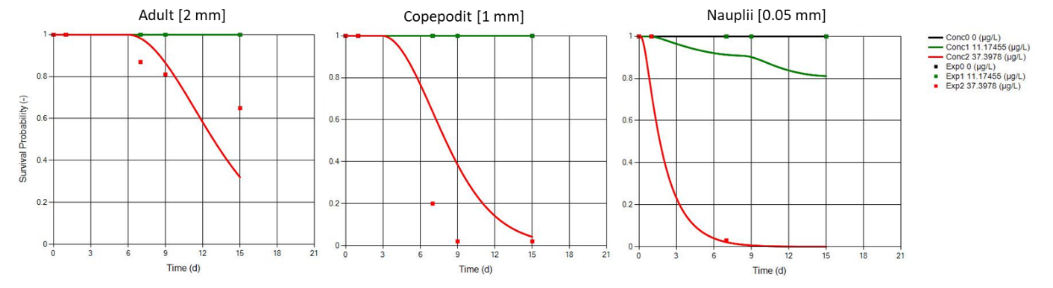
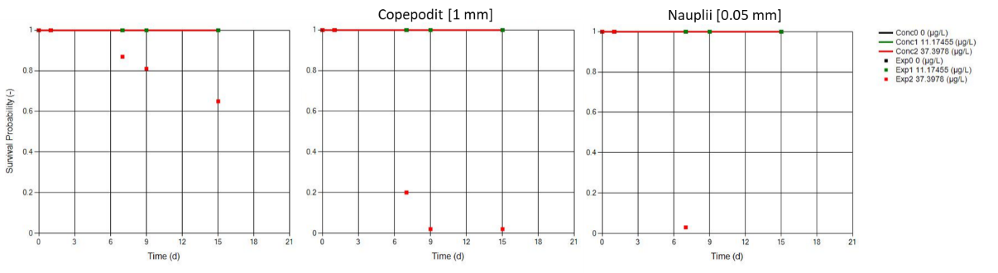
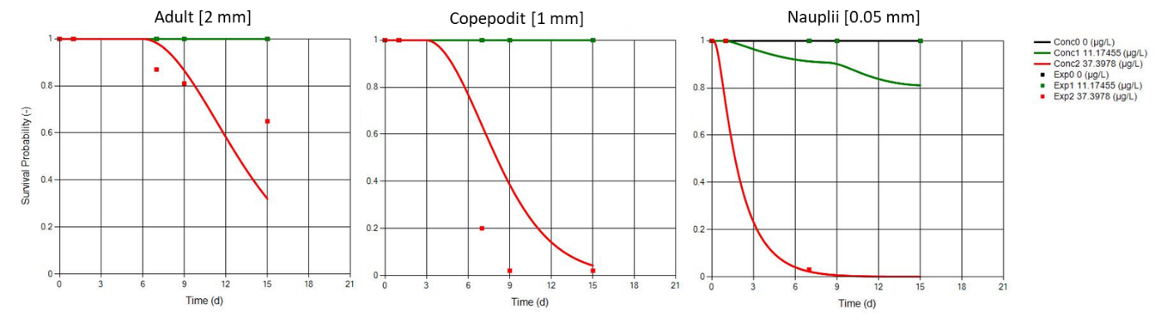
Figure 3: Simulations of copepod survival using mesocosm data 2019b (red: 30 µg/L exposure scenario, green: 10 µg/L exposure scenario); dots: mesocosm data, lines: simulations. X-axis: day after first application in the mesocosm study. Upper panels: GUTS parameters obtained from the laboratory study (OpenGUTS); lower panels: GUTS parameters calibrated to mesocosm data with size dependence of the copepods (GUTSplus). Left: adult copepods with 2mm length; middle: Copepodits with an assumed mean length of 1 mm; right: Nauplius larvae.

Table 2: GUTS calibrations considering mesocosm data (see text for explanation).
Parameter | kd | z | kk | Study information*
Description | dominant  rate constant | threshold  for lethal effect | killing rate
Unit | 1/d | µg/L | l/(µg*d) | References | size /  stage | calibration program
Daphnia longispina | 2.508 | 28 | 0.09368 | Mesocosm study 2019b | first instar | GUTSplus
Cyclopoid copepods | 0.0539 | 9 | 0.025 | Mesocosm study 2019b | 2 mm | GUTSplus

All calibrations based on the laboratory data are shown graphically in Appendix A (Chapter 7: Appendix A: GUTS parametrisation).

Other toxicological approaches

Inhibition of growth rates in phytoplankton as a function of toxic concentration in water is implemented in the StoLaM model as an ECx approach.
However, it was decided not to include the available effect data for algae in this project. First, most ECx values were well above the highest concentration in the 2019b mesocosm study.
In addition, there is no clear evidence of direct adverse effects for the exposure scenarios in the mesocosm studies. On the contrary, most phytoplankton-related endpoints tend to show promotions at high toxicant levels.
Only for the fluorescence values assigned to the cryptophyceae, slight acute adverse effects cannot be excluded, but especially for this group of algae no test data from the laboratory are available.
To summarise, it should be emphasised that no toxic effects were therefore taken into account in the simulation of phytoplankton.

Result overview and short discussion

Direct effects

Daphnids
(see result chapter 4.1.1)

In the simulations, Daphnia shows clear effects after application in the 30 µg/L scenario with clear undercutting of the MDD values and a very similar effect curve as derived from the mesocosms. The recovery has an almost identical timing as in the mesocosms, particularly well visible in the figure with log-scaling.
In the 10 µg/L scenario, the initial decrease in abundance is already visible before application in the field data of the mesocosms, so a clear toxic effect cannot be assumed here. Subsequently, the daphnia show no negative deviation from the controls that falls below the MDD. In the simulations, no clear effect can be seen, which confirms the transferability of the used TKTD (GUTS) parameterisation.
Overall, by integrating the TKTD effect model into the IBM daphnia model, the effect size and the recovery for both high exposure scenarios can be well catched with this simulation approach.

Copepods
(see result chapters 4.1.2 and 4.1.3)

The simulated naupliar larvae and the sum of the older cyclopoid copepod stages show a very realistic effect in the 30 µg/L scenario, whereby the mortality rate for the small stages (nauplii) is higher than for the larger ones.
As this is an IBM Model, all individuals are simulated individually but at the same time, and are only summarised as nauplii or larger stages for the simulation output. The size-dependent sensitivity in the course of individual development and the temporal interaction of sensitive stages and temporal exposure play an important role.
In the 10 µg/L scenario, there is no (nauplii) or only a very slight negative short-term effect (older copepods) on the population detectable, which corresponds well with the field data.

Due to the physiological parameterisation of the DEB-IBM copepod model, which is not yet fully developed, the late recovery of older copepod stages cannot yet be satisfactorily represented. In particular, the lifespan under suboptimal feeding and temperature conditions still needs to be revised.
Another problem for the development of the nauplii larvae could be the somewhat too high simulated densities for daphnia and rotifers, which change the feeding conditions to the disadvantage of the nauplii.
However, this is not seen as a problem in principle of this approach, but rather of the still outstanding, more intensive model testing of the new developed copepod module.
All in all, the IBM copepod model makes it possible to apply the TKTD effect model to the population, and to integrate size-dependent sensitivities to the toxic substance.

Indirect effects

Rotifers
(see result chapter 4.1.4)

The rotifers show clear and strong long lasting indirect promotion in the 30 µg/L scenario, which agrees very well in the timing of both the onset of the effect and its recovery with the field data.
In the 10 µg/L scenario, on the other hand, no significant effect on rotifers is detectable either in the field data nor the simulations.

Phytoplankton
(see result chapter 4.2)

In the total phytoplankton, the abundance in the mesocosms is significantly increased over 2 weeks in the 30 µg/L scenario approx. 14 days after application. This promoting, indirect food effect can be reproduced well with the model as a result of decreased grazing pressure by daphnids and copepods.
Again, in the 10 µg/L scenario, no significant effect on algae is detectable in either the field data or the simulations in the 7 weeks following application.

Mainly responsible for this promoting effect in the 30 µg/L scenario are the green algae, which show clear significant promoting effects in the mesocosms as well as in the simulations. Here, the oscillating overshooting is partially well matched in both timing and magnitude.

Diatoms show no clear effect in the 30 µg/L scenario in the 8 weeks after application, with only a small but non-significant increase two weeks after application visible in both measurements and simulations.
The reduction in diatom fluorescence signal that occurs late in the study cannot be represented by the model.

The cryptophyceans are basically not well covered in the simulation at the moment, especially the increase of the fluorescence signal in the mesocosms is not representable in the model, because the cryptophyceans with their productivity are an essential part of the zooplankton food. Therefore, a reduction of cryptophyceans detectable very late in the field study in the 30 µg/L scenario compared to the controls is not reproducible in the model, because there are already too few cryptophyceans in the simulated controls.

Chaoborus crystallinus
(see result chapter 5.1.1)

Mesocosm data for Chaoborus larvae from the macroinvertebrate dataset were used to compare field data and simulation.

On day 177, one single but significant NOEC of 10 µg/L was found in the mesocosm experiment with an MDD of 25 %, indicating a possible slight adverse effect on Chaoborus larvae abundance.
The simulated deviations on larval abundance in the 30 µg/L exposure scenario from the controls due to the toxic substance alone from the day of application ranged from -3.6% to +7.6% (mean + 1.7%), and were thus within the range of variations between Monte Carlo simulations (data not shown graphically). Therefore, a direct toxic effect based on the GUTS calibrations with laboratory studies can be excluded.

But indirect adverse dietary effects could be simulated for the 30 µg/L exposure scenario as described below:
In the IBM Chaoborus model, the larval stages L1 and L2 feed on rotifers and nauplii larvae, the older stages (L3 and L4) on daphnids.
To simulate the indirect food effects, the relative change over time from the StoLaM simulation of the 30 µg/L scenario of daphnia, nauplii and rotifers was evaluated and given to the IBM Chaoborus model as a data input (see Figure 4).

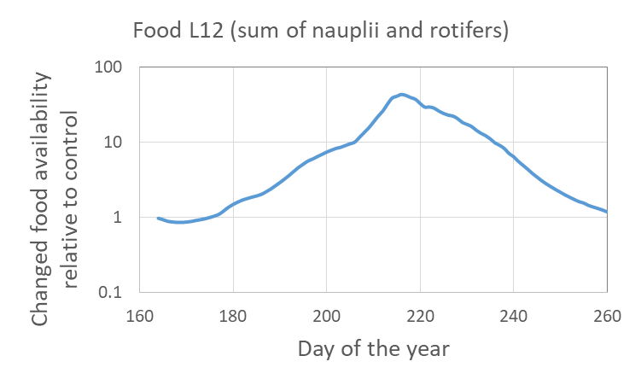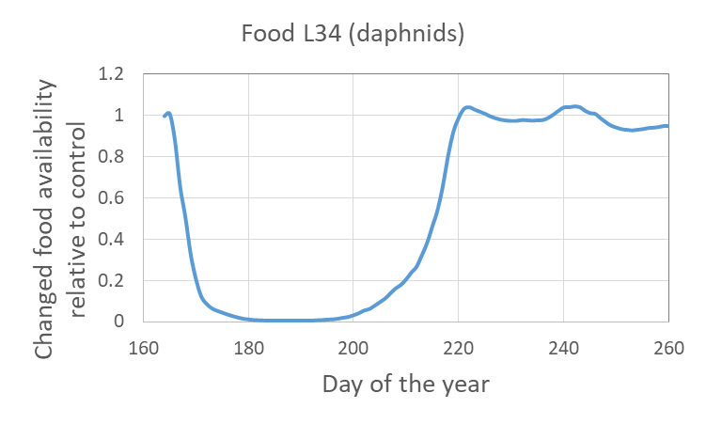
Figure 4: Simulated relative changes (StoLaM) output in the 30 µg/L scenario compared to the control for the sum of nauplii and rotifers (left panel) and daphnids (right panel) used as an influencing factor on the food availability of the respective Chaoborus larval stages.

The simulation of the 30 µg/L scenario shows the simulated strength of the diet-related indirect effects in the range of the measured MDD values. Therefore, an indirect effect on the Chaoborus population cannot be excluded. In any case, with the model approach, the pattern of the mesocosm studies can be well reproduced within the model concept, and thus hypotheses can be established and substantiated.

Overall, a direct toxic effect on Chaoborus larvae cannot be excluded in principle. However, the simulated direct lethal effects do not show any impact on the population, on the other hand, by including reduced food availability (mainly due to direct effects on daphnids), a similarly strong reduction in population density can be simulated for the older larvae as was found in the mesocosms. These results indicate an indirect, adverse effect.

Toxicologically unaffected benthic taxa
(see result chapter 6.1)

In the STREAMcom model, the benthic individual-based modelled taxa Asellus aquaticus, Gammarus pulex, Lymnaea stagnalis, Cloeon dipterum and Chironomus riparius were coupled with the TKTD effect model GUTS.
GUTS parameterisations from the 48 h laboratory studies with azoxystrobin using the TKTD calibration tool openGUTS were available for all 5 macroinvertebrate species (Cloeon, Gammarus, Asellus, Lymnea, Chironomus), and these were used to simulate the effects of the exposure scenarios on the populations.
However, as all threshold values for lethal effects (GUTS parameter z) were significantly above the highest simulated exposure concentration of 30 µg/L, no negative effects were observed in the simulation for any of these organisms, as expected (see result chapter 6.1). These results are consistent with the evaluation of the mesocosm study, in which no significant negative effects were observed.

Summary

- Clear direct adverse effects in the exposure scenario 30 µg/L on daphnids and copepods were found that can be well simulated with the TKTD approach.
- Significant indirect effects in the 30 µg/L exposure scenario emerged from model behavior as a result of direct effects on cladocerans and copepods: Promotion of rotifers and green algae, slight reduction of Chaoborus larvae abundance.
- For the most part, the timing of (direct and indirect) effects and their recovery was well matched (exception: recovery in copepods).
- No significant direct or indirect effects on plankton in the second highest treatment (10 µg/L exposure scenario) using the same toxicological parameterisation for the simulations.
- No adverse effects on benthic macroinvertebrates could be found in the mesocosm study as well as in the simulations using the GUTS parameter derived from laboratory short-term experiments.

Graphic results StoLaM

Zooplankton

Daphnids
Figure 5: Daphnia magna 2019, 30 µg/L exposure (data on linear scale)
Figure 6: Daphnia magna 2019, 30 µg/L exposure (data on log scale)

Figure 7: Daphnia magna 2019, 10 µg/L exposure (data on linear scale)
Figure 8: Daphnia magna 2019, 10 µg/L exposure (data on log scale)

Copepod naupli
Figure 9: Copepod nauplii 2019, 30 µg/L exposure
Figure 10: Copepod nauplii 2019, 10 µg/L exposure

Predatory (cyclopoid) copepods
Figure 11: Mesocyclops leuckarti 2019, 30 µg/L exposure

Figure 12: Mesocyclops leuckarti 2019, 10 µg/L exposure

Rotifera
Figure 13: Rotifera (Keratella cochlearis) 2019, 30 µg/L exposure
Figure 14: Rotifera (Keratella cochlearis) 2019, 10 µg/L exposure

Phytoplankton

Total Chlorophyll-a
Figure 15: Total chlorophyll-a 2019, 30 µg/L exposure
Figure 16: Total chlorophyll-a 2019, 10 µg/L exposure

Green algae
Figure 17: Green algae 2019, 30 µg/L exposure
Figure 18: Green algae 2019, 10 µg/L exposure

Diatoms

Figure 19: Diatoms (Cyclotella) 2019, 30 µg/L exposure
Figure 20: Diatoms (Cyclotella) 2019, 10 µg/L exposure

Cryptophytes
Figure 21: Cryptomonas 2019, 30 µg/L exposure
Figure 22: Cryptomonas 2019, 10 µg/L exposure

Graphic results IBM Chaoborus

Chaoborus crystallinus
Figure 23: Chaoborus larvae 2019, 30 µg/L exposure

Graphic results StreamCom

Macroinvertebrates

Asellus aquaticus
For Asellus, a conversion factor of 0.5 was used for the measurements and simulations in the figures.
Figure 24: Asellus aquaticus 2019, 30 µg/L exposure

Gammarus
Figure 25: Gammarus pulex 2019, 30 µg/L exposure

Gastropoda
Figure 26: Lymnaea stagnalis 2019, 30 µg/L exposure

Cloeon dipterum
For Cloeon larvae, a conversion factor of 10 was used to display the measurements and simulations in the figures.
Figure 27: Cloeon dipterum larvae 2019, 30 µg/L exposure

Chironomus riparius
For Chironomus larvae, a conversion factor of 880 was used to display the measurements and simulations in the figures.
Figure 28: Chironomus riparius larvae 2019, 30 µg/L exposure

Appendix A: GUTS parametrisation

Zooplankton

Daphnia

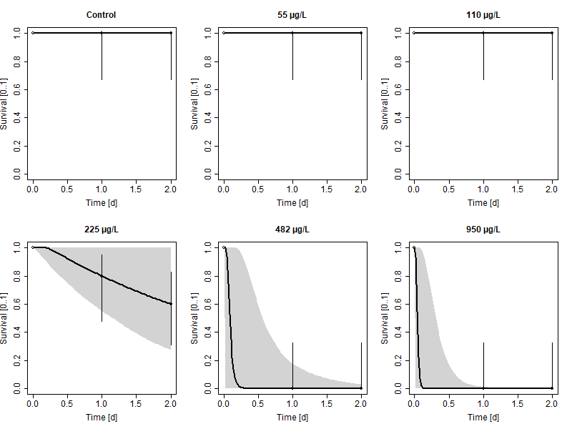
Figure 29: Daphnia magna: Survival plots for the calibration of GUTS-RED-SD (OpenGUTS)

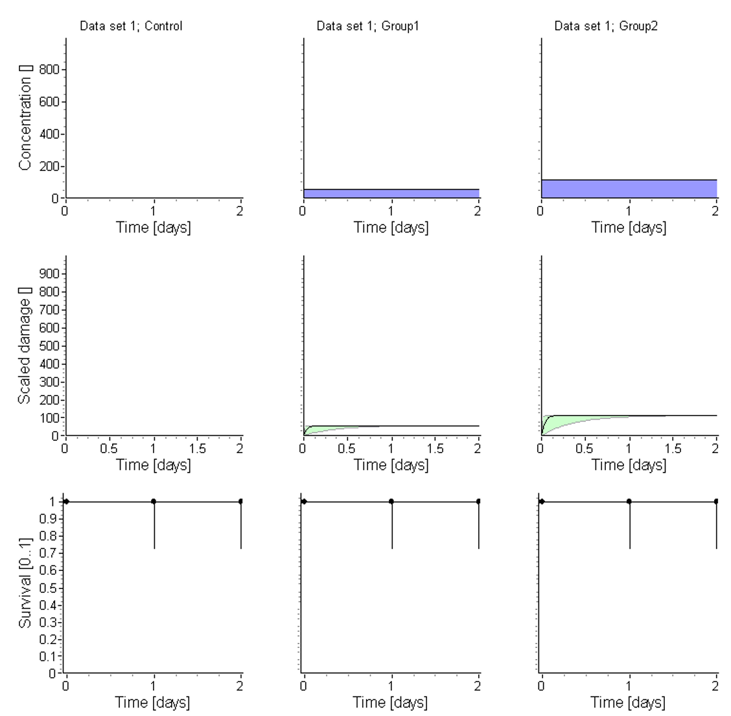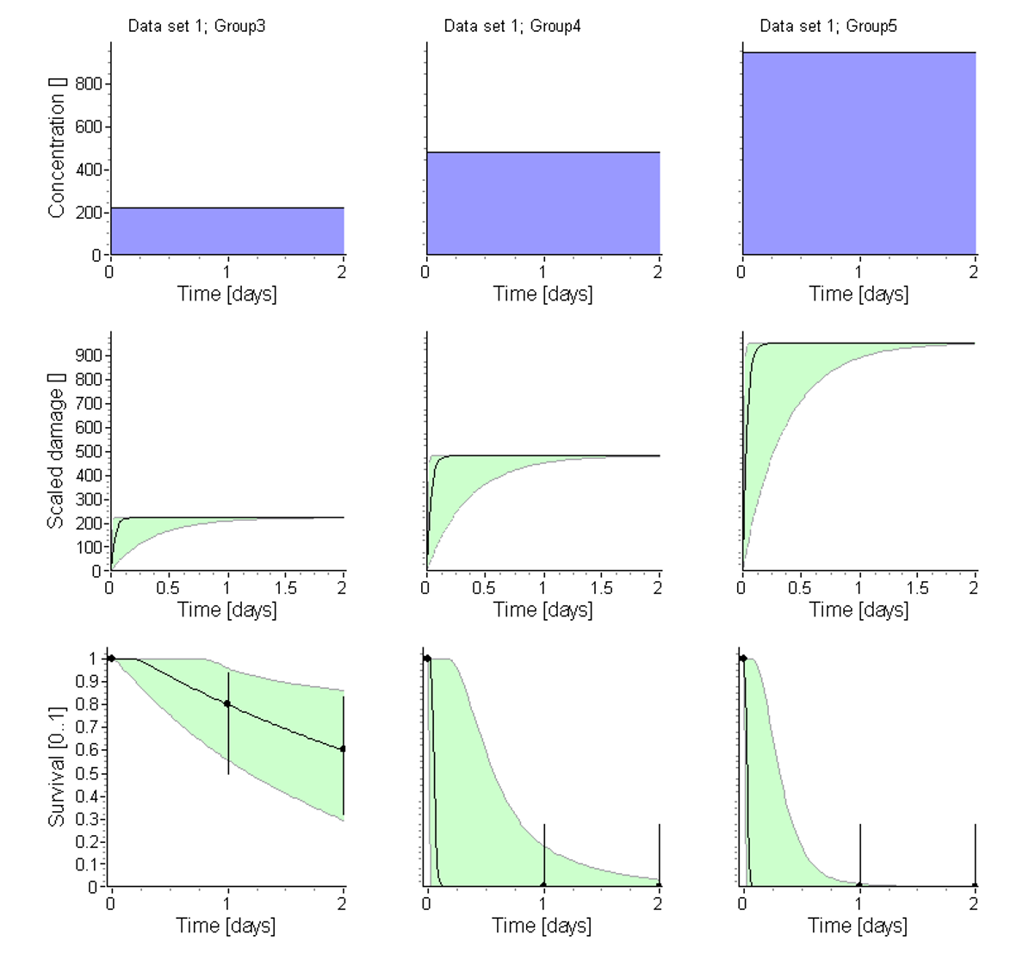
Figure 30: Daphnia magna: Exposure, damage and survival plots for the calibration of GUTS-RED-SD (OpenGUTS)
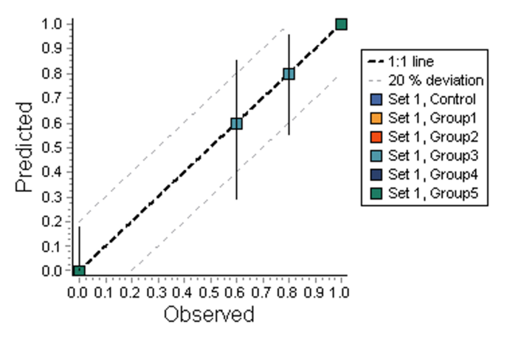
Figure 31: Daphnia magna: Observed vs. Predicted survival (PPC) plot for the calibration of GUTS-RED-SD (OpenGUTS)

Copepods

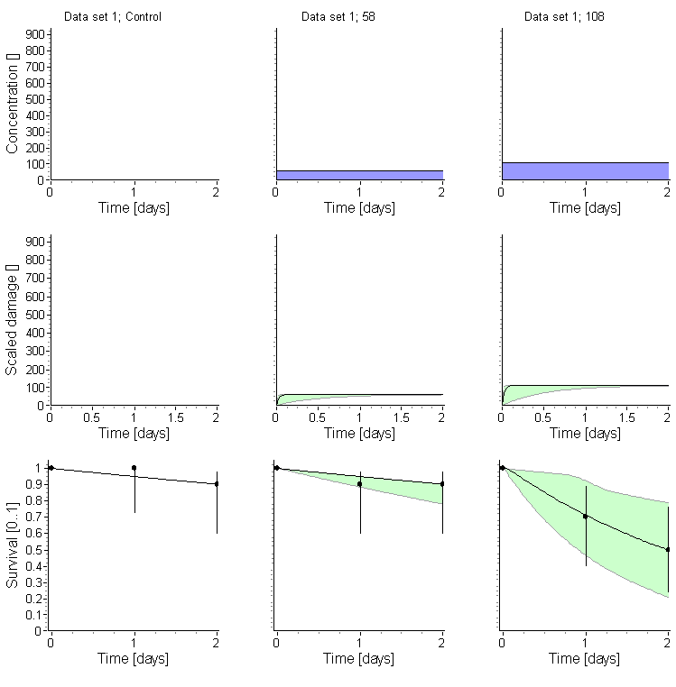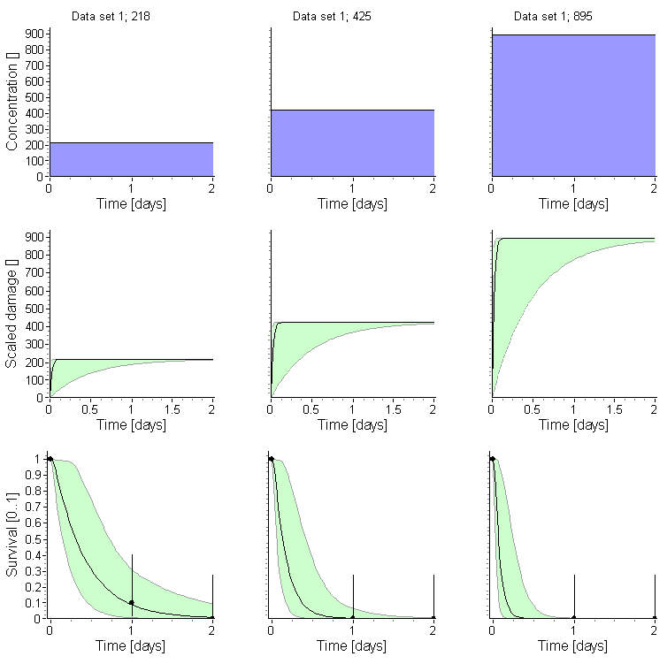
Figure 32: Macrocyclops fuscus: Exposure, damage and survival plots for the calibration of GUTS-RED-SD (OpenGUTS)
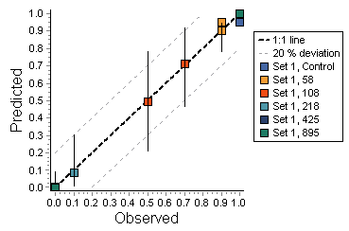
Figure 33: Macrocyclops fuscus: Observed vs. Predicted survival (PPC) plot for the calibration of GUTS-RED-SD (OpenGUTS)

Chaoborus crystallinus

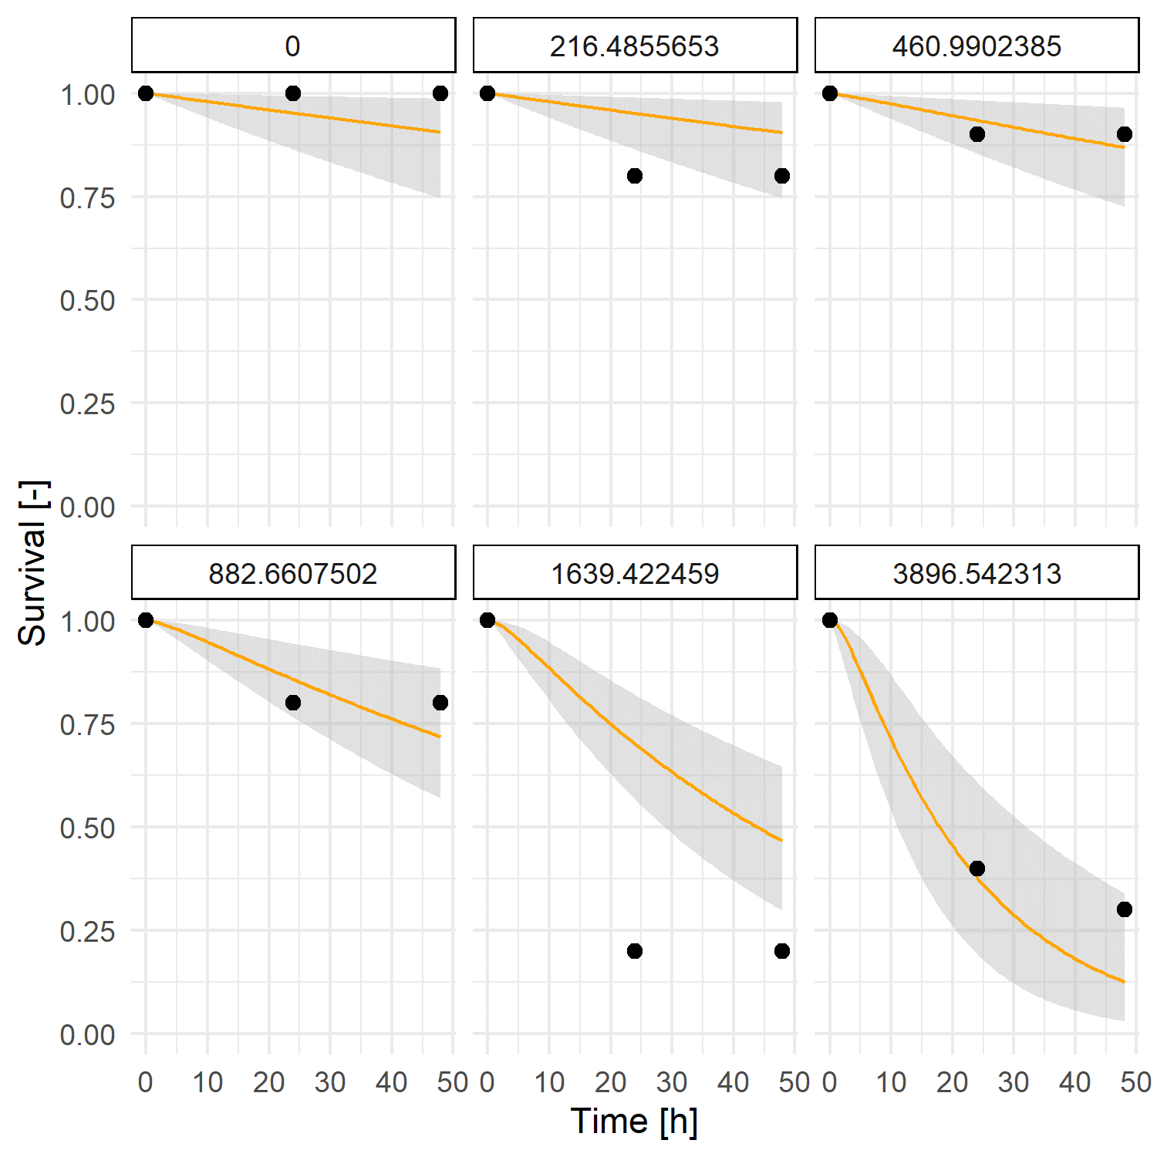
Figure 34: Chaoborus crystallinus: Survival plots for the calibration of GUTS-RED-SD (MORSE)

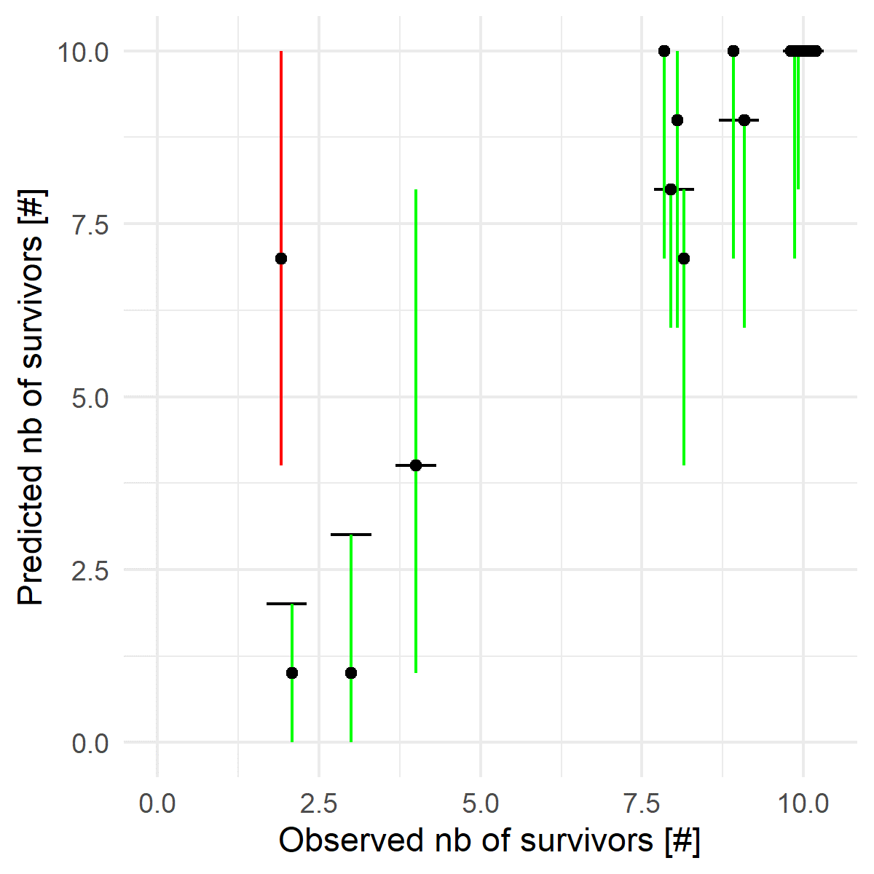
Figure 35: Chaoborus crystallinus: Observed vs. Predicted survival (PPC) plot for the calibration of GUTS-RED-SD (MORSE)

Macroinvertebrates

Cloeon dipterum

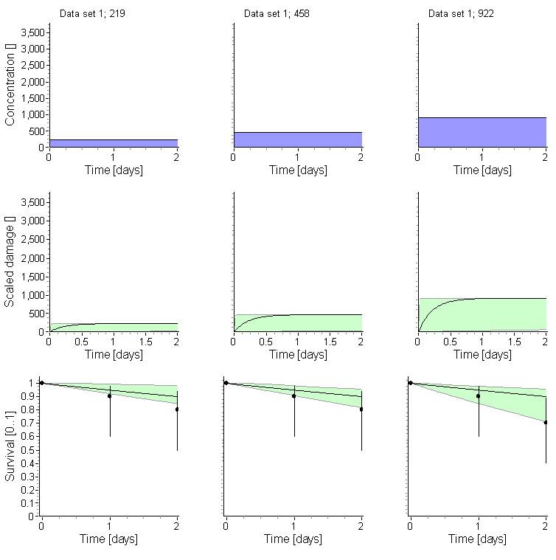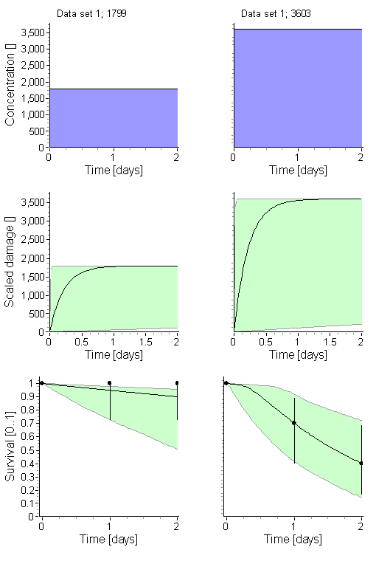

Figure 36: Cloeon dipterum: Exposure, damage and survival plots for the calibration of GUTS-RED-SD (OpenGUTS)
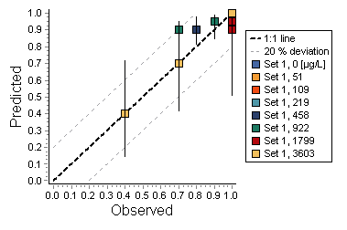
Figure 37: Cloeon dipterum: Observed vs. Predicted survival (PPC) plot for the calibration of GUTS-RED-SD (OpenGUTS)

Gammarus pulex
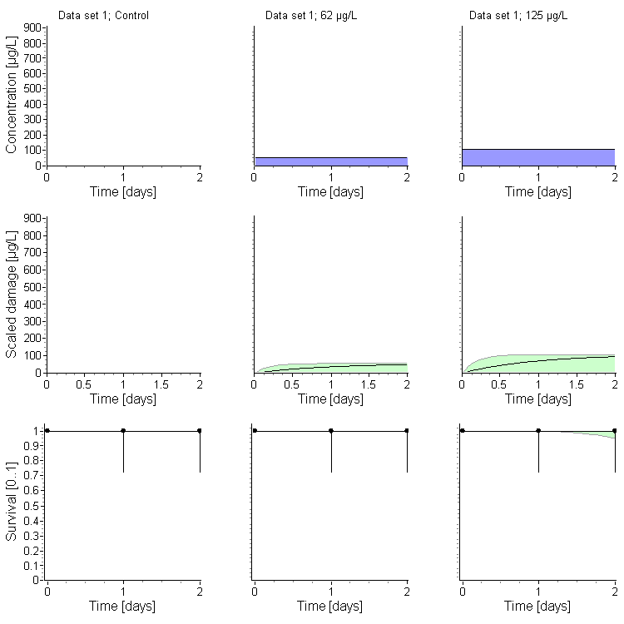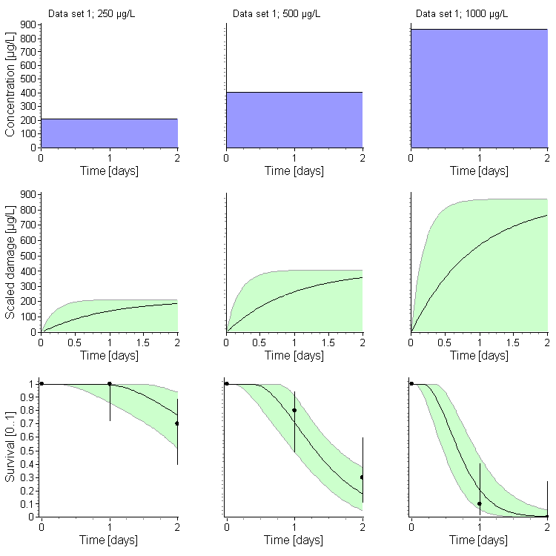

Figure 38: Gammarus pulex: Exposure, damage and survival plots for the calibration of GUTS-RED-SD (OpenGUTS)

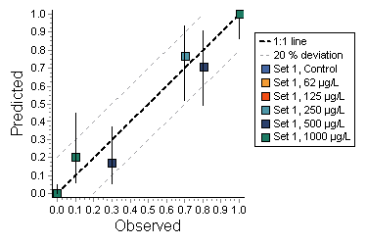
Figure 39: Gammarus pulex: Observed vs. Predicted survival (PPC) plot for the calibration of GUTS-RED-SD (OpenGUTS)

Asellus aquaticus

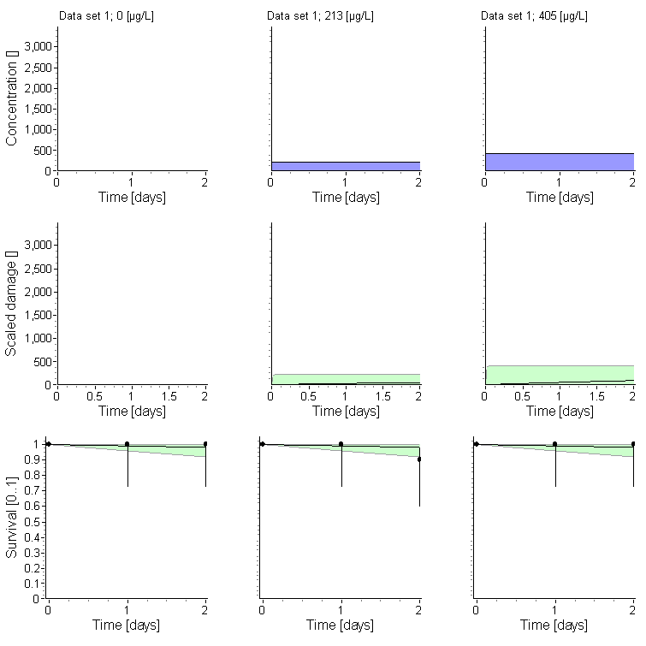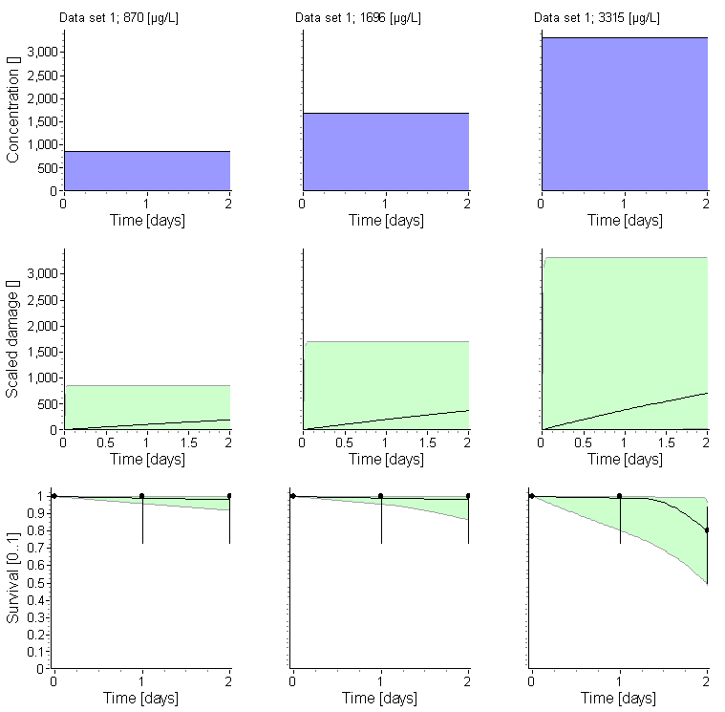

Figure 40: Asellus aquaticus: Exposure, damage and survival plots for the calibration of GUTS-RED-SD (OpenGUTS)

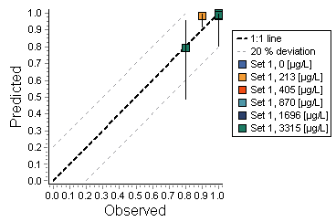
Figure 41: Asellus aquaticus: Observed vs. Predicted survival (PPC) plot for the calibration of GUTS-RED-SD (OpenGUTS)

Lymnea stagnalis

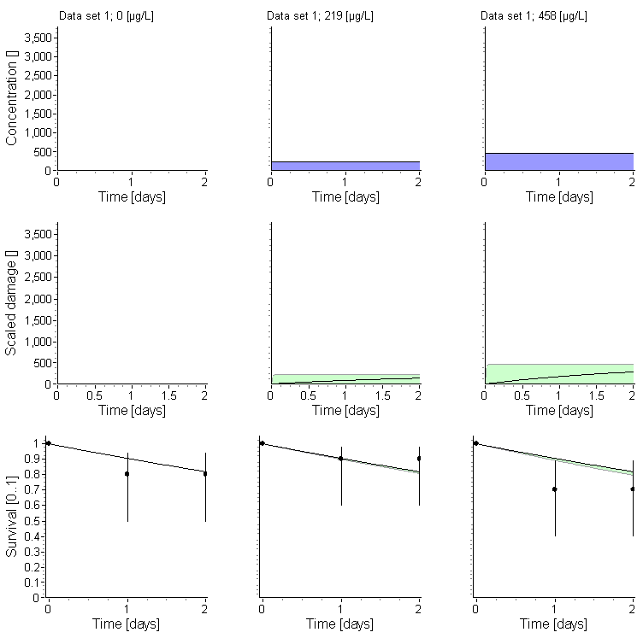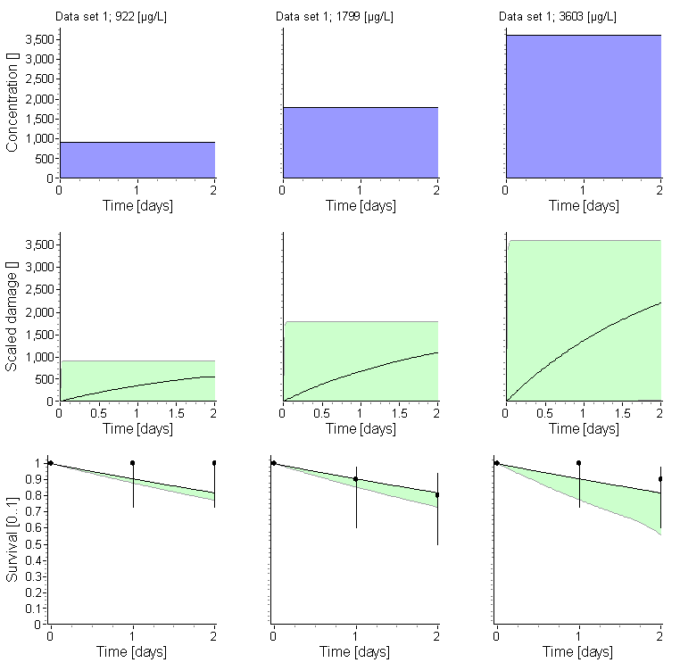

Figure 42: Lymnaea stagnalis: Exposure, damage and survival plots for the calibration of GUTS-RED-SD (OpenGUTS)

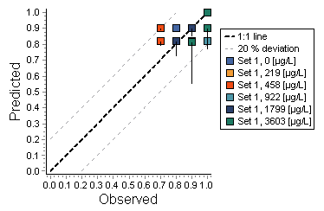
Figure 43: Lymnaea stagnalis: Observed vs. Predicted survival (PPC) plot for the calibration of GUTS-RED-SD (OpenGUTS)

Chironomus riparius

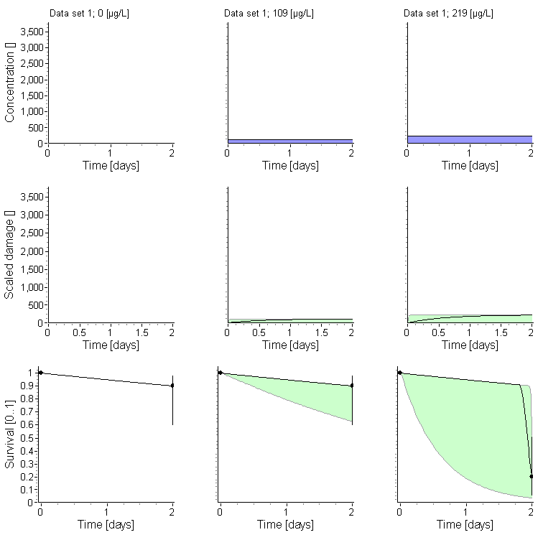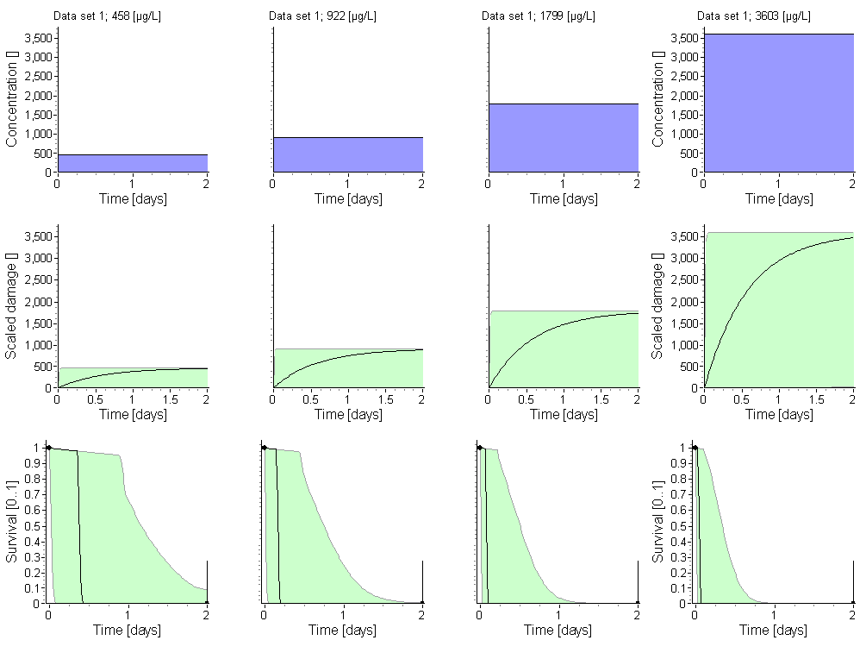

Figure 44: Chironomus riparius: Exposure, damage and survival plots for the calibration of GUTS-RED-SD (OpenGUTS)
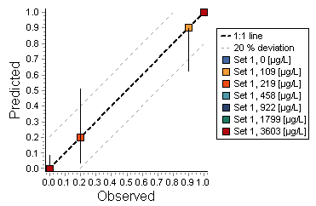
Figure 45: Chironomus riparius: Observed vs. Predicted survival (PPC) plot for the calibration of GUTS-RED-SD (OpenGUTS)

